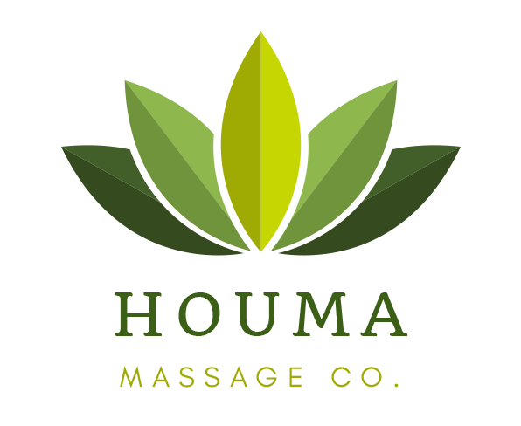
What the Cup?
Massage Cupping therapy is an adaptation of an ancient technique that dates
back as early as 1550 B.C. The cup is positioned over the area of the body to be
treated and suction is created using a vacuum gun or bulb. The more traditional
method involves inserting a flame into a glass cup to create the vacuum. The
suction level can range from light to heavy, and the movements performed by
the therapist can be stimulating or sedating. These cups are moved over the
skin using gliding, shaking, popping and rotating techniques while gently pulling
up on the cup, or may be parked for a short time to facilitate joint mobilization
or soft tissue release. This suction reaches deep into the soft tissue, attachments
and organs to help improve circulation + lymph flow.

What are the benefits of cupping?
- Decreases and relieves pain and
inflammation
- Releases deep muscular issues
- Releases and softens scar tissue
- Lifts and stretches soft tissue
- Increases range of movement
- Opens chest and lungs
- Improves circulation
- Drains lymph fluid + clear drainage
pathways
- Sedates the nervous system
- Opens energy flow of the body
- Clears old residue out of the muscle and
soft tissue
What is the discoloration that occurs after some treatments?
The discoloration, called a cup kiss, indicates the release of intense stagnation
(body fluids and toxins) in the area. This is not a bruise and will dissipate
anywhere between a few hours and a few days.

